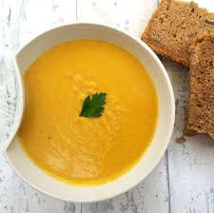
Carrot and Lentil Soup
This soup is delicious, easy, cheap and freezes very well. Anyone who has every done any cookery classes with me will probably know this recipe already – definitely a favourite.
I don’t recommend buying expensive cookery equipment but this recipe uses a stick blender to blend the soup. You can get them for under £10 from supermarkets and they’re really useful, especially for soups. You could use a masher instead or leave the soup chunky if you don’t have one.
You will need
1 tablespoon oil
700g of carrot chopped (no need to peel unless you want to)
2 medium onion, chopped
3cm ginger, peeled and chopped (ginger measurements are never very clear – if you like ginger use lots, if not use less..)
4 cloves of garlic, peeled and chopped
100g red lentils (about 3 handfuls)
700ml vegetable stock (a stock cube or teaspoon of stock powder and 700ml water is about right)
What to do
Heat the oil in a big pan and fry the carrots, onions, ginger and garlic for about 5 minutes. Frying the vegetables at the start of making a soup makes the flavours stronger even if you don’t have time/get bored and only do it for a couple of minutes.
Add the red lentils and stir them in.
Dissolve the stock cubes or powder in the hot water and pour into the pan.
Bring to the boil and then down to a simmer.
Cover the pan and cook for about 25 minutes until the vegetables and lentils are soft.
Blend up with a stick blender until it’s smooth. Depending how you like it you can add extra stock or water to make it a bit less thick.
Taste and add salt and pepper if you want to.

